**Line sensing notes**

**The criteria:**

**What are we measuring?**

**What does the measurement depend on?**

**What are we gonna use the measurement for?**

**How are we gonna take the measurements?**

**What problems are gonna affect the measurements?**

**How are we gonna control the problems and the what the measurements depend on?**

**Tasks to do measurements:**

**Wavelengths of sun light and fluorescent light:**

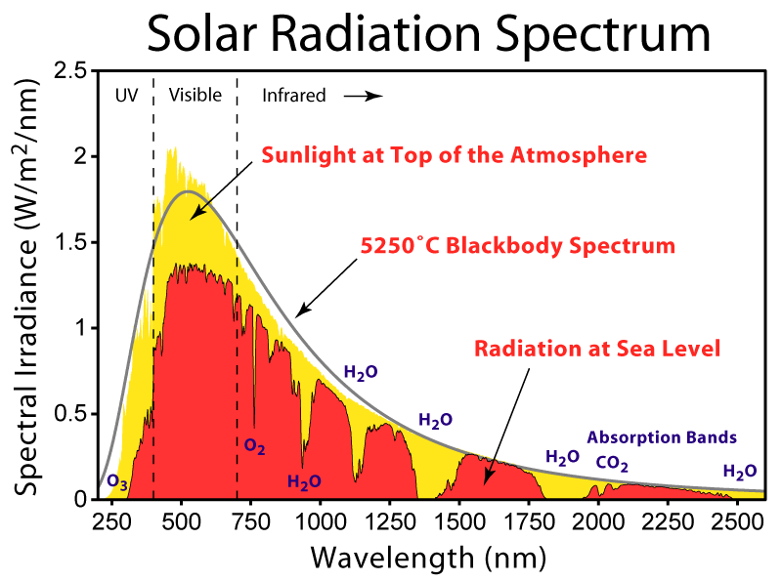

**At 900nm sun light peaks are low but at 850 they are kinda high, 1000nm to 1250nm are high irradiance,**

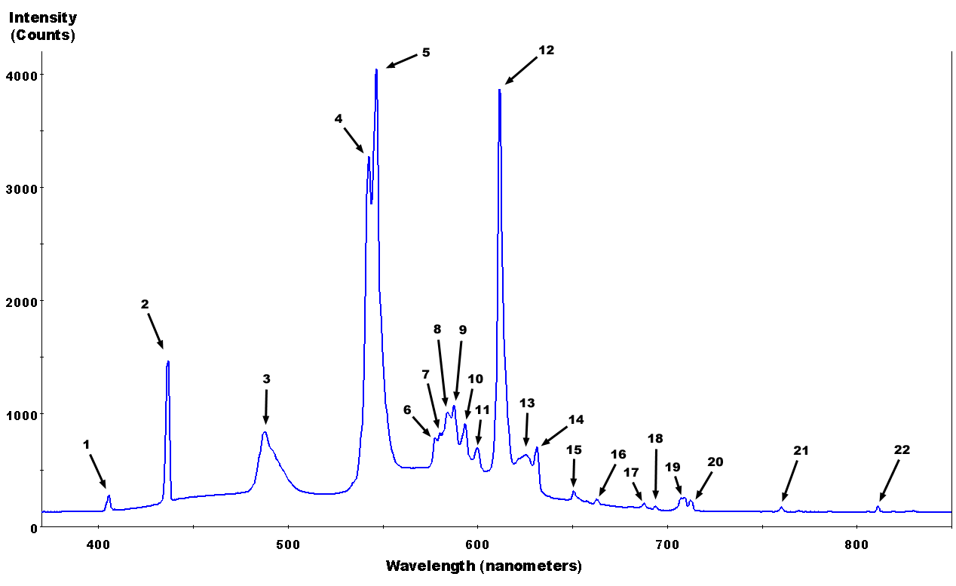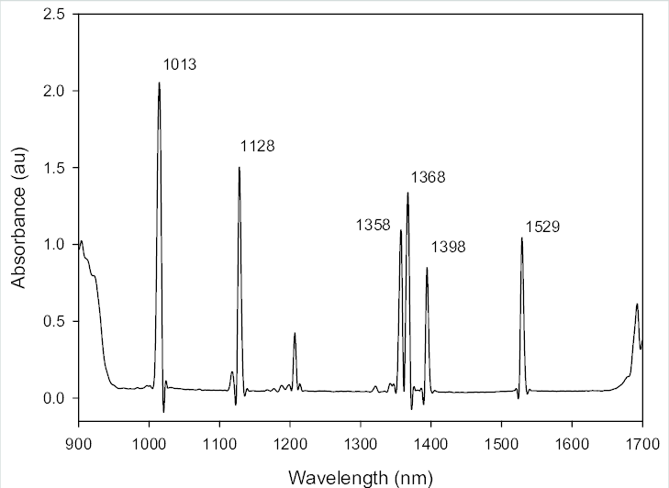

**Flourescent has high absorbance from 900 to 950 and from 1000 to 1013 and 1100 to 1128nm**

Options that avoid both these:

Bpw could be heavily affected by sunlight but not fluorescent

List of controls:

Height

Light

Voltage and current to resistor

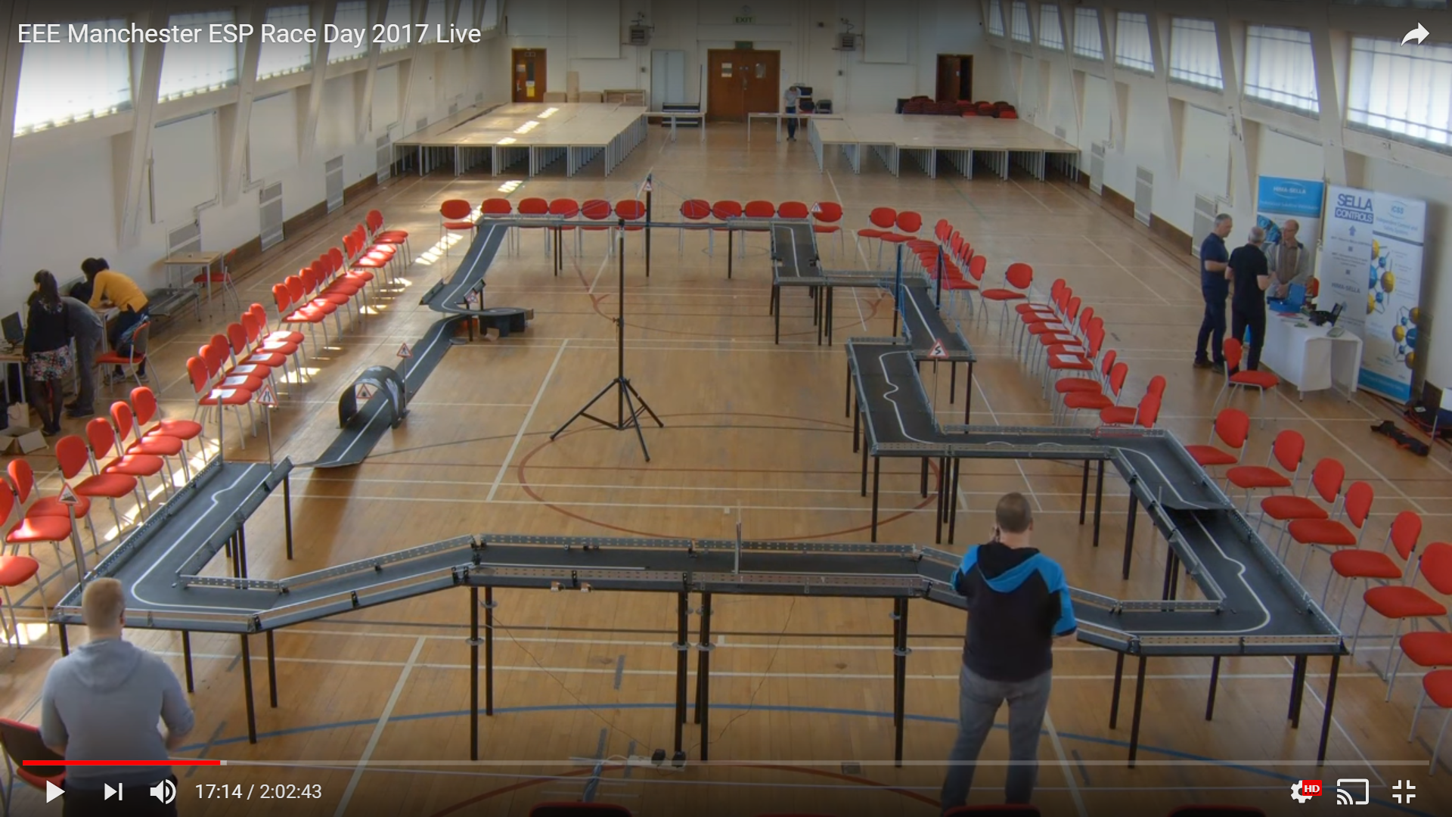\

Need to test for:

Sensor under ambient light and under sunlight included and external light. All conditions of light should be kept constant on track.

ALL Sensor at a range of heights

ALL Sensor displacement

One chosen sensor under different resistance and under 3 different displacement heights at which the sensor is most sensitive

After sensors chosen cross talk between sensors has to be tested for

Demonstrate on and off control of led using digital out/in

Demonstrate on and off of detector using current buffer

Test chosen sensor with line breaks

Report requirements:

Which line have we chosen and why

A table characterizing the sensors characteristics

Will our sensor work in sunlight?

How will our sensor cope with line breaks?

Show how we have fully characterized our sensor

**Photodiodes:**

When photons hit the base of the pn junction electron hole pair is created in depletion region and then a current flows

While phototransistors have a higher [responsivity](https://en.wikipedia.org/wiki/Responsivity) for light they are not able to detect low levels of light any better than photodiodes.

In photo voltaic or zero bias:

When used in zero [bias](https://en.wikipedia.org/wiki/Bias_(electrical_engineering)) or ***photovoltaic mode***, the flow of photocurrent out of the device is restricted and a voltage builds up.

In reverse bias, photoconductive:

Positive connected to negative (cathode) of the photo diode and negative connected to positive of photodiode (anode)

For a spectral range, this mode will allow the current to be linearly proportional to illuminance.

Light shining on the photodiode causes its resistance to the reverse bias current to decrease.

However;

Increases dark current

Reduces response time as the depletion region gets larger so the capacitance gets lower

The current produced by the led flows from cathode to anode

**How to choose the resistor:**

The current output depends on the amount of photocurrent:

Higher light means more current, more current means greater output voltage

1. Resistor needs to be able to produce output in volts so needs to be larger than 400000 ohms
2. Resistor needs to produce a output voltage in bright levels that is at the max voltage of 3.7 V

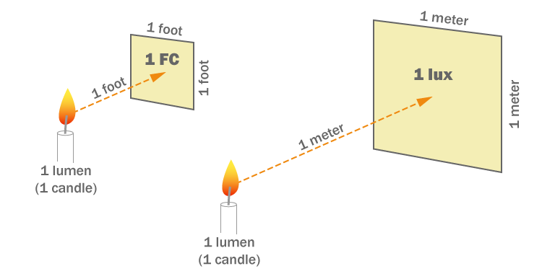

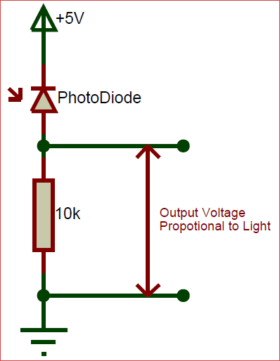

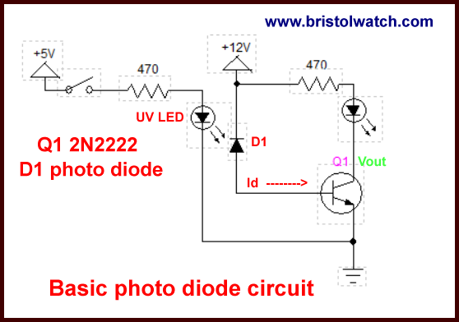(this is to amplify it)

Differences to phototransistor:

May need a amplifier to be able to calculate large enough current to increase voltage output of resistor

Faster than phototransistor, Photodiodes with nanosecond and even femtosecond responses are commercially available

. Photodiodes produce only a very small amount of current, ranging from nanoamps (nA) to a few microamps (µA).

Because of their low current output they are almost always used with a transimpedance amplifier which converts their low-level, high impedance output into a usable voltage

Dark current: For photodiodes, this is the current which is allowed to flow even though the device is in absolutely dark conditions; it is also a function of internal noise.

Linearity: linear relationship between light and current is present over 7 to 9 decades

**Phototransistor:**

For the CE configuration, light causes the output to go from a high state to a low state; for the CC configuration

Max characteristics in datasheet:

The max eco and ceo are breakdown voltages that should not be applied to transistor

How a phototransistor works:

just a bipolar transistor with the base open and then the base converts photons to current

 With the base connection open circuit, the collector-base current must flow in the base-emitter circuit and hence the current flowing is amplified by normal transistor action. Collector base junction is very sensitive to light.

A phototransistor works just like a normal transistor, where the base current is multiplied to give the collector current, except that in a phototransistor, the base current is controlled by the amount of visible or infrared light where the device only needs 2 pins.

**How are we gonna choose a transistor resistor:**

1. Transistor has to be sensitive to just between black and white surface so doesn’t have to be very sensitive
2. Resistor can’t be too large that low light causes max voltage to be reached
3. Resistor can’t be too low that the max current is reached at saturation at high light levels
4. Resistor of bpw cant be below 100 ohms

What the output Collector current depends on:

hFE increases with on temperature and VCE but in our case it wont matter much as we will fix the vcc and hence the temperature wont matter much.

Transistor load line:

VCE = VCC – Ic x Rload

Ic = hFE x Ibase

changing is resistance of base junction gives Ibase, Rbase

Rbase depends on light levels and will decrease for higher light levels

Rload needs to allow Rbase to be low enough to allow the bright levels to cause saturation of transistor and high enough to not allow the of Ic to reach max levels.

**If VCC is fixed at voltage 5V then even if Ib increases, it will not cause Ic to increase over the max allowed voltage VCC.**

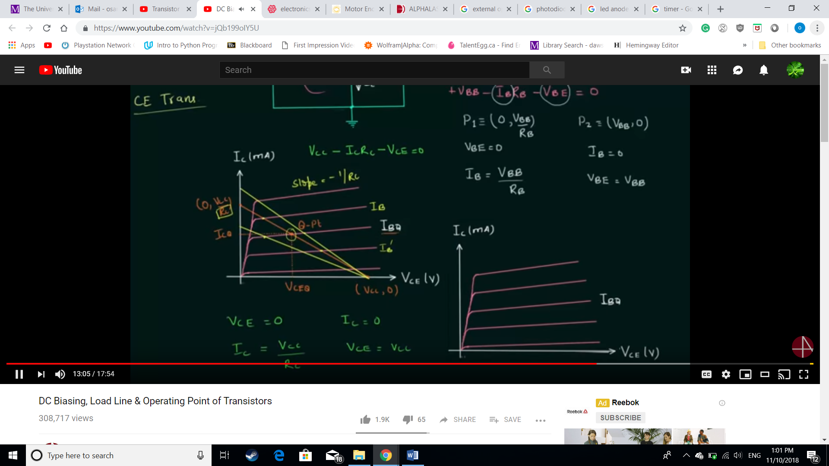

Other characteristics:

We are using common emitter:

Phototransistors can be used as analog or digital output components;

When analog, phototransistor is used in active mode i.e the VCC > Ic x R

When digital, phototransistor is used in switch mode i.e VCC< Ic x R

Dark current: For phototransistors, the dark current is the leakage current of the collector-base junction multiplied by the dc current gain of the transistor. It prevents the phototransistor from being completely “off” as an ideal switch.

Linearity of light intensity to current: the linearity of light intensity to collector current in phototransistors is across three to four decades

Decades: a scale of 10 difference between two increments on a graph

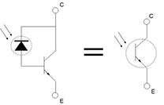 phototransistor 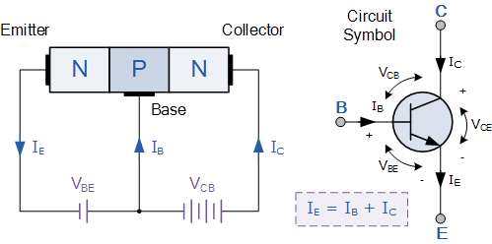

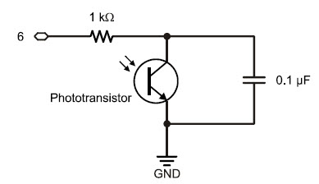(I don’t know if we should use this or not)

This kind of phototransistor/capacitor circuit is called a charge transfer circuit. The Arduino will determine the rate at which each capacitor loses its charge through its phototransistor by measuring how long it takes the capacitor’s voltage to decay, that is, to drop below a certain voltage value. The decay time corresponds to how wide open that current valve is, which is controlled by the brightness of the light reaching the phototransistor’s base. More light means faster decay, less light means slower decay.